**Name**:___________________________ **Date**:______________

**Year & Block**: _____________________ **Score**: ______________

**Laboratory Activity 1**

**Instructions:**

Do the following tasks inside your Ubuntu server (text-based). Write down the commands you used.

1. Go to your own **username directory** under /home.
2. Inside it, create a folder named **Documents**.
3. Inside **Documents**, create this directory structure with files:

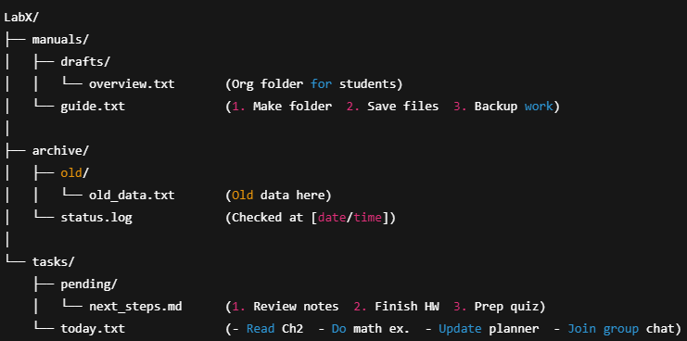

| **Criteria** | **Excellent** | **Satisfactory** | **Needs Improvement** | **Points** |
| --- | --- | --- | --- | --- |
| 1. Folder Structure | All folders are correct. (20 pts) | One folder mistake. (15 pts) | Many folder mistakes. (10 pts) |  |
| 2. Files & Content | All files and content correct. (20 pts) | 1–2 small mistakes. (15 pts) | Many wrong or missing. (10 pts) |  |
| 3. Neatness | Very neat and clear. (10 pts) | A little messy. (7 pts) | Hard to read or messy. (5 pts) |  |

**Total:**